**Functional Requirements Document for Health Index Calculator**

**Contents:**

1. Introduction 3
   1. Purpose 3
   2. Scope 3
2. Functional Requirements 3
   1. Input Form 3
   2. Health Score Calculation 4
   3. Output & Display 4
   4. Reset Functionality 5
3. Non-Functional Requirements 5
   1. Usability 5
   2. Performance 5
   3. Compatibility 5
   4. Accessibility 6
4. User Interface Requirements 6
5. Validation Rules 6
6. Assumptions and Constraints 7

**Link to the Project:-** [**https://yalanuwu.github.io/Health-Index-Calculator/**](https://yalanuwu.github.io/Health-Index-Calculator/)

**1. Introduction**

**1.1 Purpose**

The purpose of this document is to outline the functional requirements of the Health Index Calculator web application. This tool allows users to input basic health-related parameters (age, pulse rate, and blood pressure) to generate a health score and corresponding health status remarks.

**1.2 Scope**

The application provides an interface to:

Input personal health data.

Validate the data.

Calculate a health score based on predefined logic.

Provide meaningful visual feedback.

Offer suggestions based on the results.

**2. Functional Requirements**

**2.1 Input Form**

F1.1: The system must accept user input: Name, Age, Pulse (via dropdown), and Blood Pressure (Systolic & Diastolic).

F1.2: Name must contain only letters and spaces.

F1.3: Age must be a number ≥ 18.

F1.4: Pulse must be selected from the given BPM ranges.

F1.5: Systolic BP must be between 80 and 150 mmHg.

F1.6: Diastolic BP must be between 50 and 99 mmHg.

F1.7: Form submission must trigger the calculate() function without reloading the page.

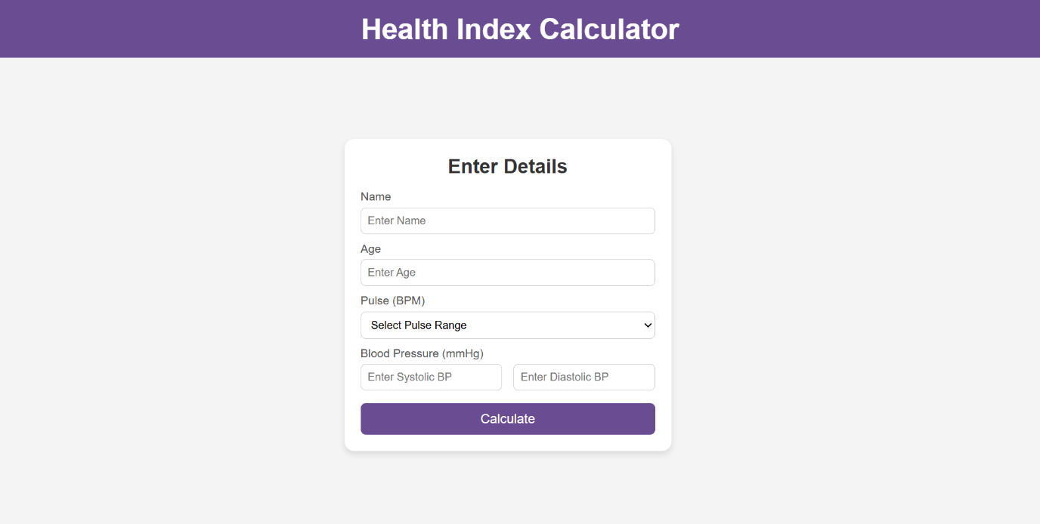

**2.2 Health Score Calculation**

F2.1: Age score is calculated based on the user's age.

F2.2: Pulse score is derived from selected BPM.

F2.3: BP score is calculated based on a validated range of systolic and diastolic pressure.

F2.4: The average of age score, pulse score, and BP score is scaled to a score out of 100 (health index).

F2.5: An alert is shown if the BP and pulse scores differ by 4 or more (indicating inconsistency or risk).

F2.6: An alert is shown if BP values fall outside expected bounds.

**2.3 Output & Display**

F3.1: Display the user's name and result prominently on the result card.

F3.2: Show total health score out of 100.

F3.3: Show individual scores: Age Score, Pulse Score, and BP Score out of 10.

F3.4: Display a remark based on score:

90–100: EXCELLENT

75–89: GOOD

50–74: AVERAGE

30–49: POOR

<30: CRITICAL

F3.5: Change background colour of result card based on remark.

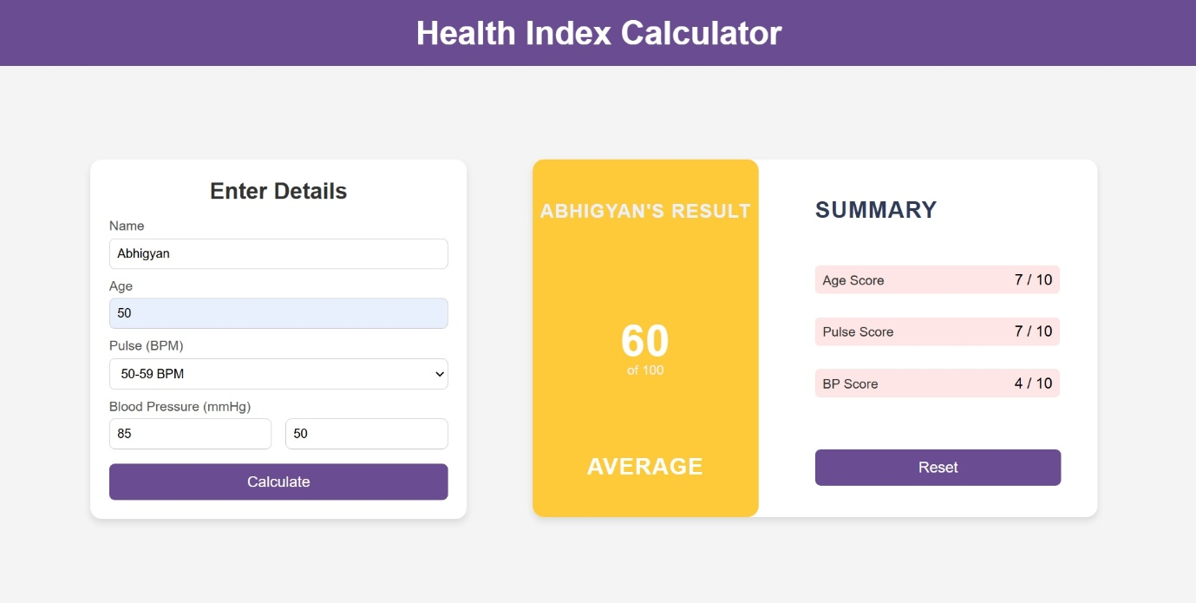

**2.4 Reset Functionality**

F4.1: Provide a “Reset” button to clear all inputs and hide result section.

**3. Non-Functional Requirements**

**3.1 Usability**

UI must be simple, responsive, and user-friendly.

Font sizes and colors must be easily readable.

**3.2 Performance**

Calculations and DOM updates should occur within 1 second.

**3.3 Compatibility**

The application must work across modern web browsers (Chrome, Firefox, Edge).

**3.4 Accessibility**

Form fields must include labels and required attributes for basic accessibility.

**4. User Interface Requirements**

UI1: Header with application name.

UI2: Centered input card for data entry.

UI3: Hidden result card that displays upon successful submission.

UI4: Visual score summary with circular health index box.

UI5: Animations and transitions for smooth user experience.

**5. Validation Rules**

Field Rule

Name Only alphabets and spaces

Age Integer ≥ 18

Pulse Must select an option

Systolic BP Between 80–150 Diastolic BP Between 50–99

Systolic BP is less than 80 or greater than 150 → show alert

Diastolic BP is less than 50 or greater than 99 → show alert

Systolic BP and Diastolic BP are within valid ranges but do not form a valid pair according to the scoring conditions → show alert

Condition ranges for BP Scoring:

Diastolic BP - Systolic BP:

50-59 – 80-89 -- Score : 4

60-69 – 90-109 -- Score : 7

70-85 – 110-130 -- Score : 10

86-89 – 131-139 -- Score : 7

90-99 – 140-149 -- Score : 4

Example Scenarios:

|  |  |  |  |  |
| --- | --- | --- | --- | --- |
| SBP | DBP | Condition | BP Score | Alert Triggered |
| 115 | 75 | Matches Score = 10 (Ideal BP) | 10 | No |
| 100 | 65 | Matches Score = 7 (Near Ideal BP) | 7 | No |
| 140 | 95 | Matches Score = 4 (At Risk) | 4 | No |
| 125 | 95 | Mismatch: SBP = "10", DBP too high | - | Yes |
| 140 | 60 | Mismatch: SBP = "At Risk", DBP too low | - | Yes |
| 75 | 45 | Out of Range | - | Yes |
| 165 | 100 | Out of Range | - | Yes |

Score Difference If BP and pulse scores differ by 4 or more → show alert

Age:

if (age >= 18 && age <= 35) age_score = 10

else if(age > 35 && age <= 55) age_score = 7

else if(age > 55 && age <= 75) age_score = 5

else age_score = 3

Pulse:

value="2" -- Below 40

value="4" -- 0-49 BPM

value="7" -- 50-59 BPM

value="10" --0-80 BPM

value="7" -- 1-90 BPM

value="4" -- 91-100 BPM

value="2" -- Above 100

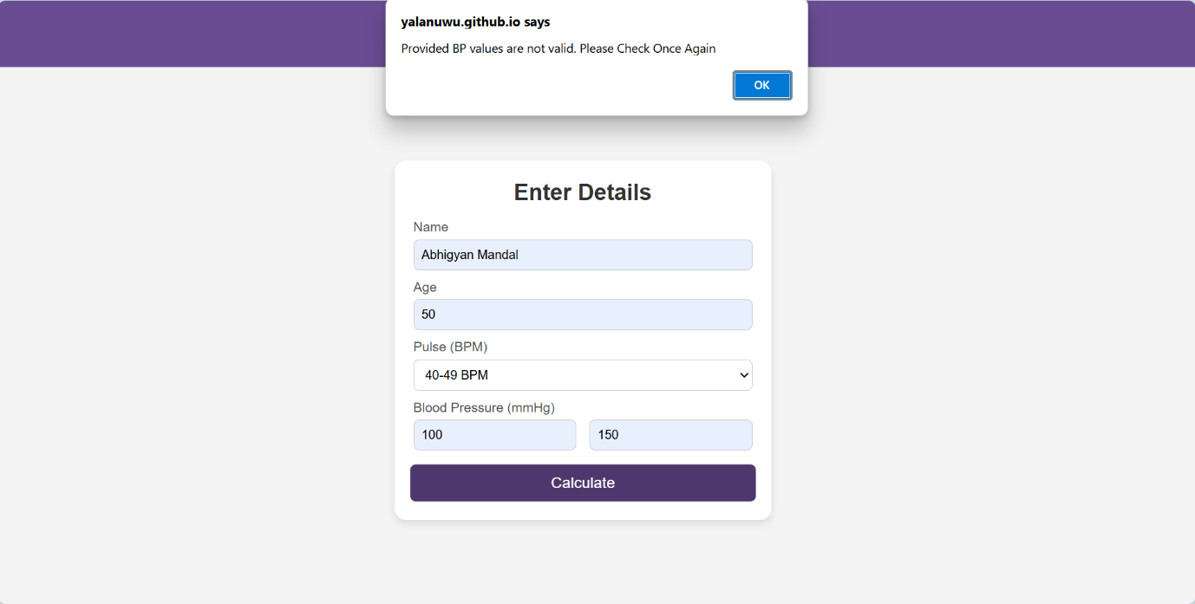

**6. Assumptions and Constraints**

Assumes user inputs realistic values.

No persistent data storage.

Not intended for medical diagnosis.